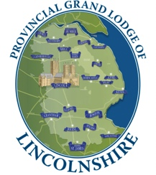
﻿2025 Festival Finale Celebration Dinner

Booking Form
TITLE | NAME | LODGE & No. | DIETARY/ALLERGY NEEDS
(W Bro, Bro, Mr, Mrs, Ms, Miss etc.) |  | (If applicable) | (Please specify: Veg/gluten free etc.)

1
Email and phone number of booking contact

2

3

4

5

6

7

8

9

10

 | Number | AT | TOTAL
EITHER Number of meals @ £65 booked before June 30 |  | £65.00 | £
OR Number of meals @ £69 booked after June 30 & before Aug 29 |  | £69.00 | £
House Red Wine – number of bottles reqd. |  | £23.00 | £
House White Wine – number of bottles reqd. |  | £23.00 | £
Pinot Grigio Rose Wine – number of bottles reqd. |  | £23.00 | £
Prosecco – number of bottles reqd. |  | £31.75 | £
Car parking – number of vehicles |  | FREE
Disabled parking – number of vehicles (BLUE badge holders only)  (Please supply Car Registration number with booking) |  | FREE
BACS Transfer (preferred) to Provincial Grand Lodge of Lincolnshire:  Sort code: 53-50-10 Account number: 04319257  Cheques made payable to PGL of Lincolnshire |  | TOTAL | £

Please send payment and completed booking form* to:
Provincial Office, Cambridge Road, Grimsby, DN34 5SZ Tel: 01472 870042 e-mail: office@pgllincs.org
*Submit your form in whatever way suits you best – electronically, printed, handwritten, scanned, or posted.
All methods are acceptable!

